Week 6: Product Review and Rating Management System Scenario:
The e-commerce company wants to collect customer feedback about purchased
products. Customers can provide ratings and reviews after completing their orders. The system should store customer opinions, analyze product performance, and identify highly rated products.
Students will create a Product Review and Rating Module connected with the existing Customer and Product modules.

Tasks to be Done:
- Create Review and Rating Tables
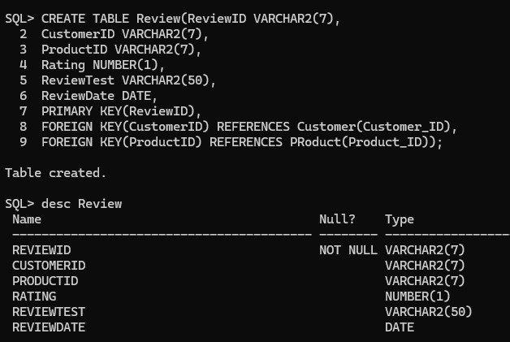

Store Customer Feedback and Ratings Tasks:
  - Add reviews for purchased products.

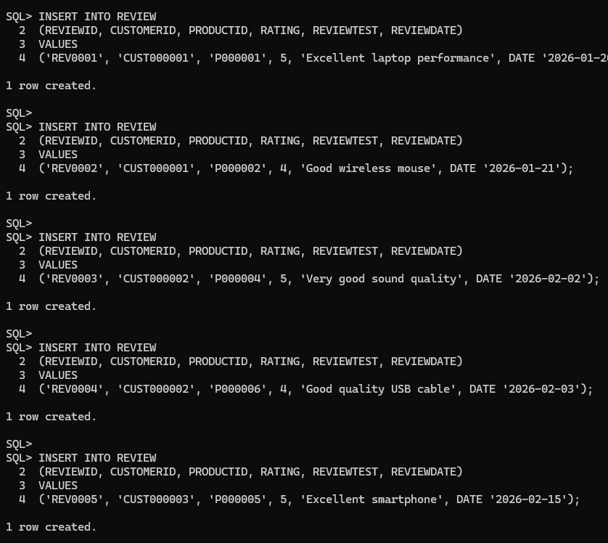

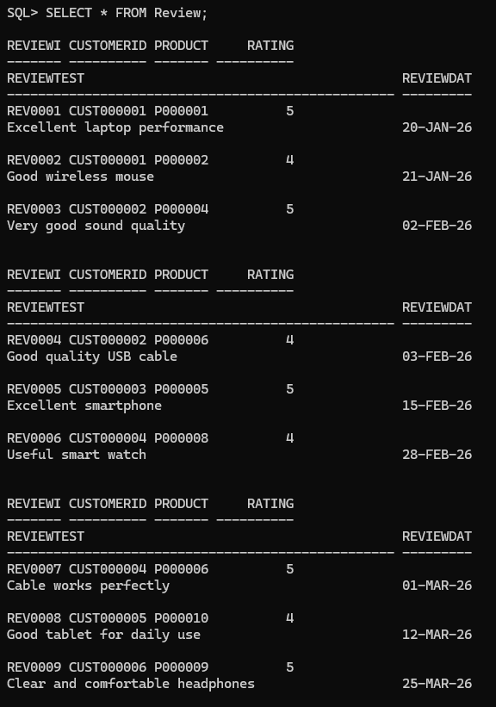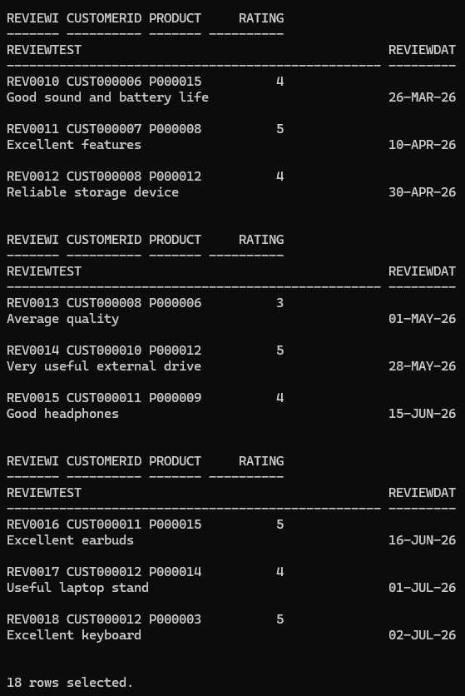
  - Store customer ratings from 1 to 5 stars.

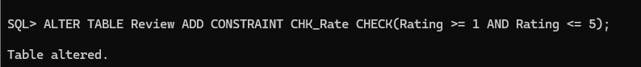
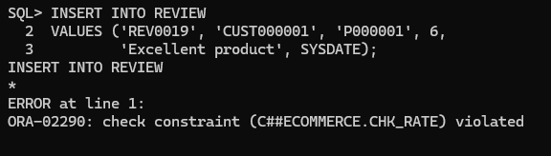
Ensure this by adding Constraint

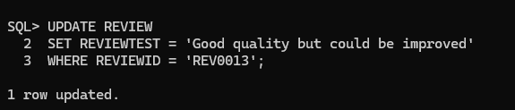
  - Update review comments if required.
  - Remove inappropriate or invalid reviews.
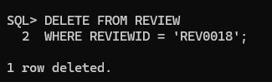

Retrieve Product Review Details Write SQL queries to:
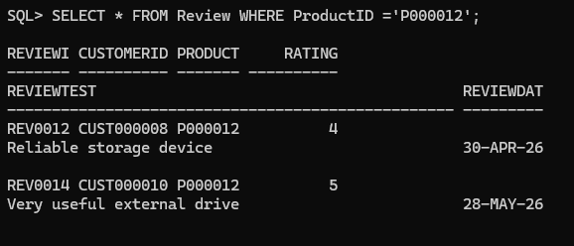
  - Display all reviews for a product.
  - Display customer name with their reviews.

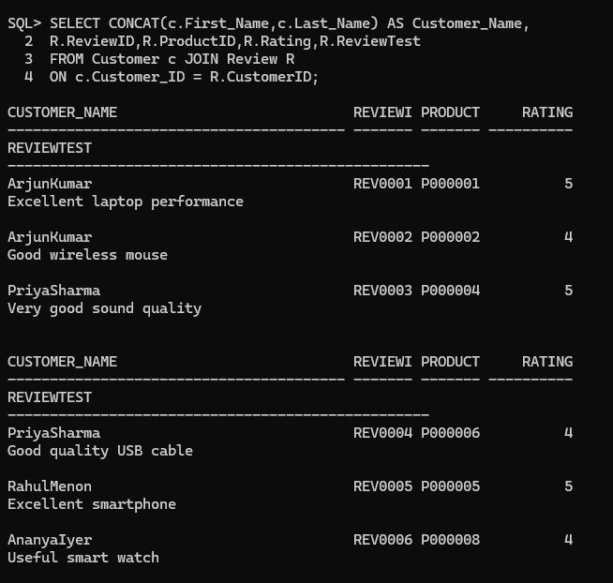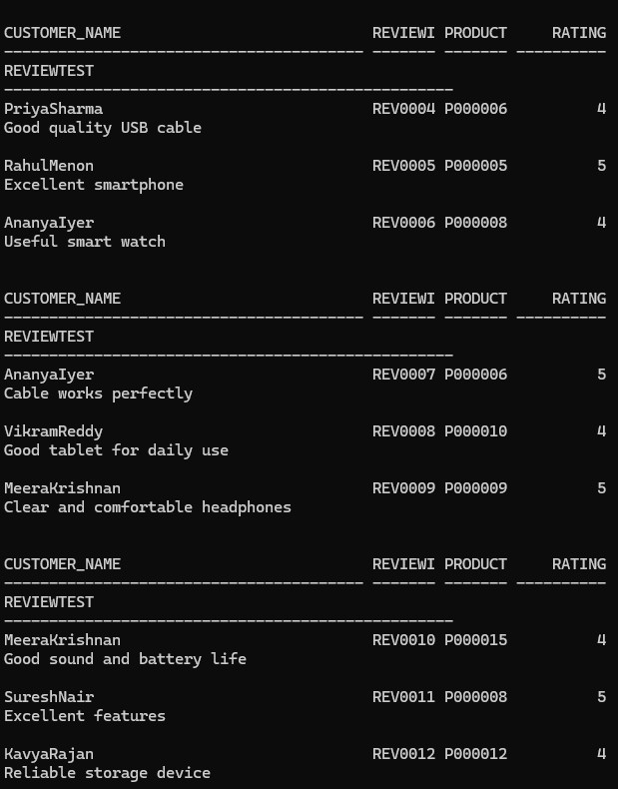

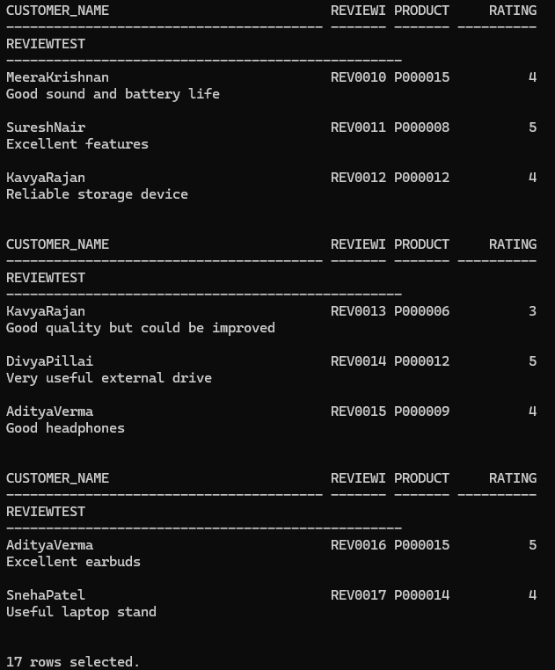
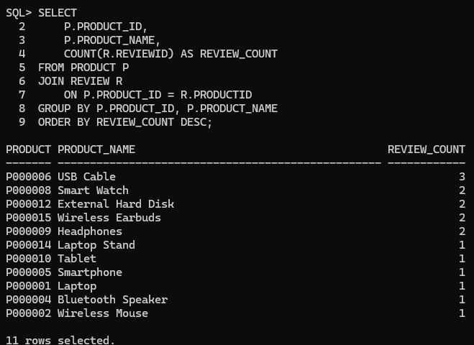
  - Find products having maximum reviews.

  - Display recent customer feedback.

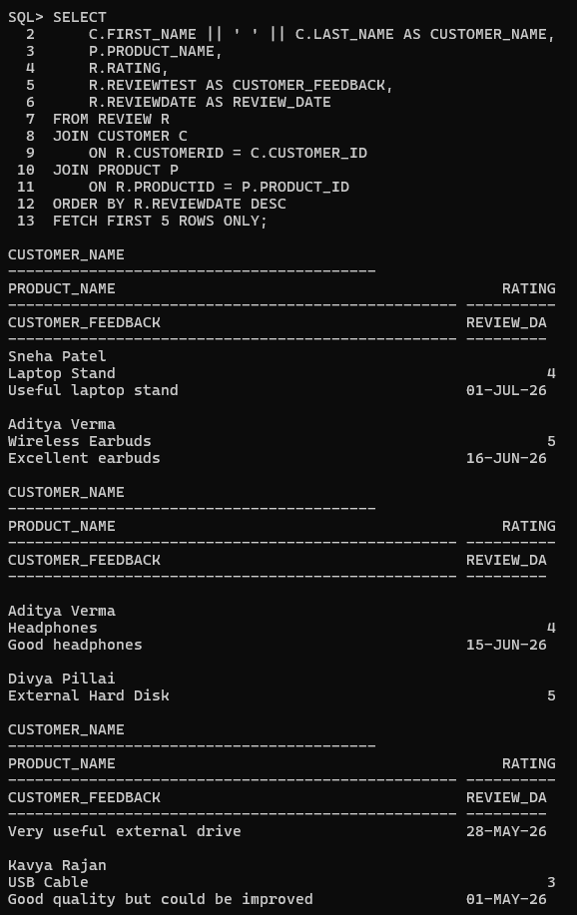
  - Retrieve reviews with ratings above 4.

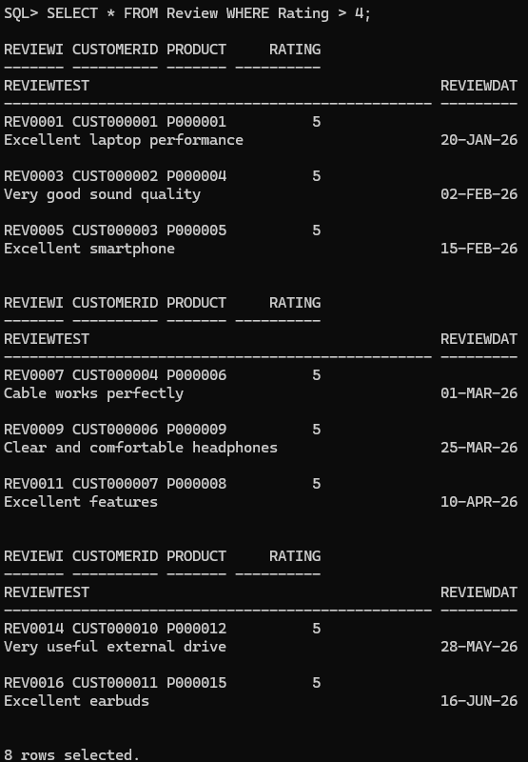

Example Query:
- Calculate Average Product Ratings
Use aggregate functions to analyze ratings.

Tasks:
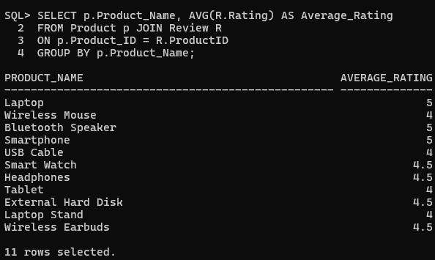
  - Calculate average rating for each product.
  - Count the number of reviews per product.

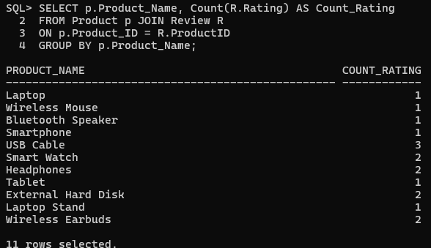
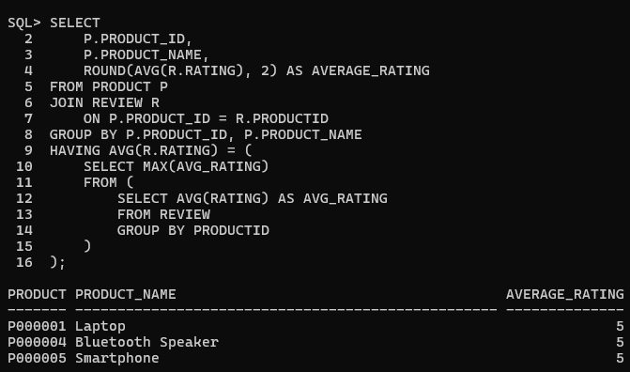
  - Find highest-rated products.
  - Identify products with average rating above 4.
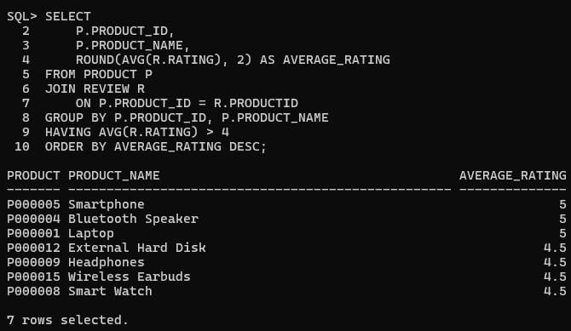
- Identify Highly Rated Products Generate product rating reports. Report 1: Product Rating Analysis Display:
- Product name
- Number of reviews
- Average rating

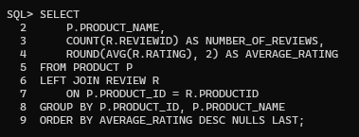
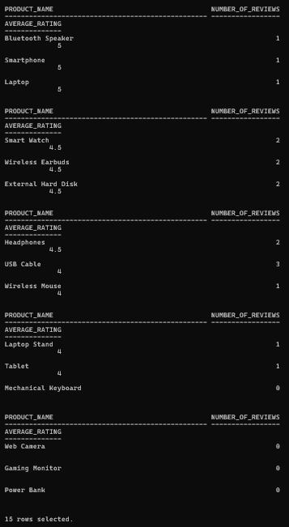

Report 2: Customer Feedback Analysis
Find:
- Most reviewed products
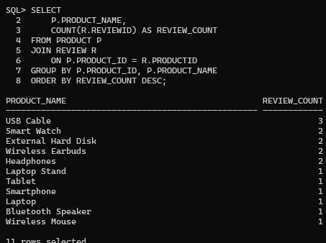
- Highly rated products

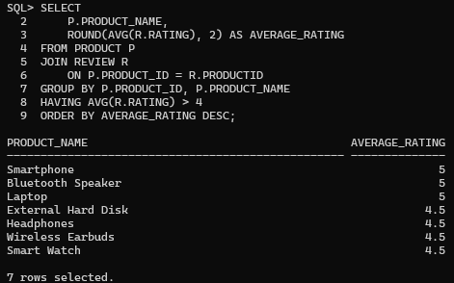
- Products requiring improvement
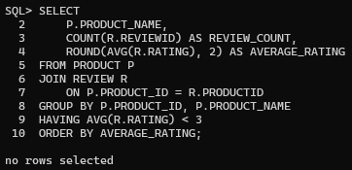

Report 3: Rating Distribution
- Number of 5-star ratings
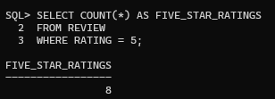
- Number of 4-star ratings
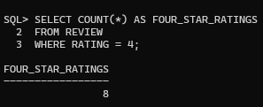
- Number of low-rated products
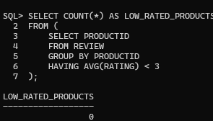
- Complete Rating
